NAME: RAJA RAYYAN AMEER
REG. NO.: 23-CP-25
SECTION: ALPHA
SUBJECT: DATABASE MANAGEMENT SYSTEM
DEPARTMENT: COMPUTER ENGINEERING
TEACHER: SIR SHAHID
LAB 3
Task 1: Design a specialization hierarchy for 'Vehicle' with types 'Car', 'Truck', and 'Motorbike'.
Query:
Table Vehicle {
vehicle_id int [pk]
brand varchar(50)
model varchar(20)
year int
}

Table Car {
vehicle_id int [pk, ref: > Vehicle.vehicle_id]
number_of_doors int
}

Table Truck {
vehicle_id int [pk, ref: > Vehicle.vehicle_id]
load_capacity int
}

Table Motorbike {
vehicle_id int [pk, ref: > Vehicle.vehicle_id]
engine_capacity varchar(20)
}
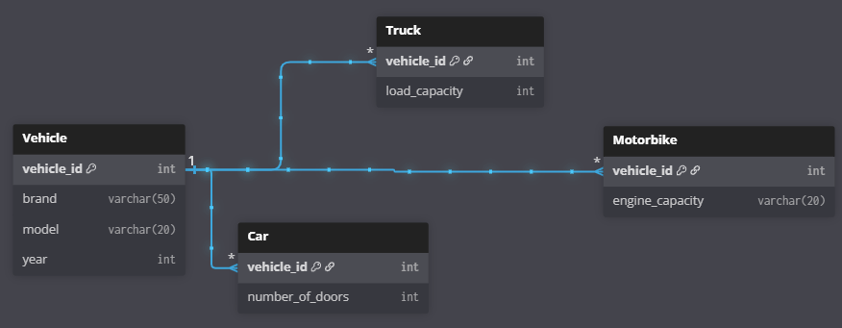
Task 2: Model an aggregation scenario involving 'Doctor', 'Patient', and 'Treatment' related to a 'Hospital'.
Query:
Table Doctor {
doctor_id int [pk]
name varchar(20)
specialization varchar(50)
}

Table Patient {
patient_id int [pk]
name varchar(20)
issue varchar(100)
}

Table Treatment {
treatment_id int [pk]
prescription varchar(200) [unique]
}

Table Treatment_Record {
record_id int [pk]
doctor_id int [pk, ref: > Doctor.doctor_id]
patient_id int [pk, ref: > Patient.patient_id]
treatment_id varchar [pk, ref: > Treatment.treatment_id]
}

Table Hospital {
hospital_id int [pk]
name varchar(100)
record_id int [pk, ref: > Treatment_Record.record_id]
}
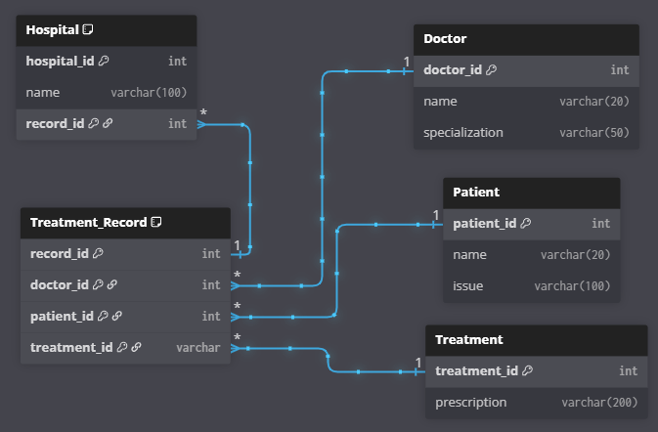
Task 3: Create a ternary relationship for 'Supplier', 'Product', and 'Warehouse'.
Query:
Table Supplier {
supplier_id int [pk]
name varchar(50)
}

Table Product {
product_id int [pk]
name varchar(50)
price decimal
}

Table Warehouse {
warehouse_id int [pk]
location varchar(50)
}

Table Delivery {
delivery_id int [pk]
supplier_id int [ref: > Supplier.supplier_id]
product_id int [ref: > Product.product_id]
warehouse_id int [ref: > Warehouse.warehouse_id]
delivery_date date
}
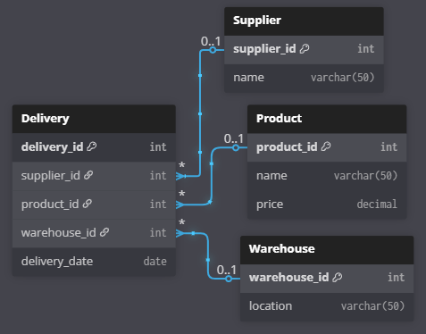
Task 4: Translate a table-per-hierarchy ER design into SQL.
Query:
CREATE TABLE Vehicle (
vehicle_id INT PRIMARY KEY,
brand VARCHAR(50),
model VARCHAR(20),
year INT,
vehicle_type VARCHAR(20),
number_of_doors INT,
load_capacity INT,
engine_capacity VARCHAR(20)
);

INSERT INTO Vehicle (vehicle_id, brand, model, year, vehicle_type, number_of_doors)
VALUES (1, 'Toyota', 'Corolla', 2022, 'Car', 4);

INSERT INTO Vehicle (vehicle_id, brand, model, year, vehicle_type, load_capacity)
VALUES (2, 'Volvo', 'FH16', 2021, 'Truck', 20000);

INSERT INTO Vehicle (vehicle_id, brand, model, year, vehicle_type, engine_capacity)
VALUES (3, 'Honda', 'CBR500R', 2023, 'Motorbike', '500cc');

SELECT * FROM Vehicle;

SELECT vehicle_id, brand, model, year, number_of_doors
FROM Vehicle
WHERE vehicle_type = 'Car';

SELECT vehicle_id, brand, model, year, load_capacity
FROM Vehicle
WHERE vehicle_type = 'Truck';

SELECT vehicle_id, brand, model, year, engine_capacity
FROM Vehicle
WHERE vehicle_type = 'Motorbike';
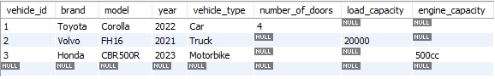
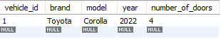
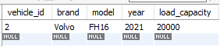
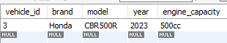
Task 5: Write SQL to retrieve all employees who are not part of any specialization.
Query:
CREATE TABLE Employee (
emp_id INT PRIMARY KEY,
name VARCHAR(50),
join_date DATE
);

CREATE Table TeachingStaff (
emp_id INT PRIMARY KEY,
FOREIGN KEY(emp_id)
REFERENCES Employee(emp_id),
subject_specialization VARCHAR(50)
);

CREATE TABLE NonTeachingStaff (
emp_id INT PRIMARY KEY,
FOREIGN KEY (emp_id)
REFERENCES Employee(emp_id),
department VARCHAR(50)
);

CREATE TABLE ContractStaff (
emp_id INT PRIMARY KEY,
FOREIGN KEY (emp_id)
REFERENCES Employee(emp_id),
contract_duration VARCHAR(20)
);

SELECT e.emp_id, e.name, e.join_date
FROM Employee e
WHERE e.emp_id NOT IN(
SELECT emp_id
FROM TeachingStaff
UNION

SELECT emp_id
FROM NonTeachingStaff
UNION

SELECT emp_id
FROM ContractStaff
);
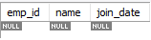
THE END

